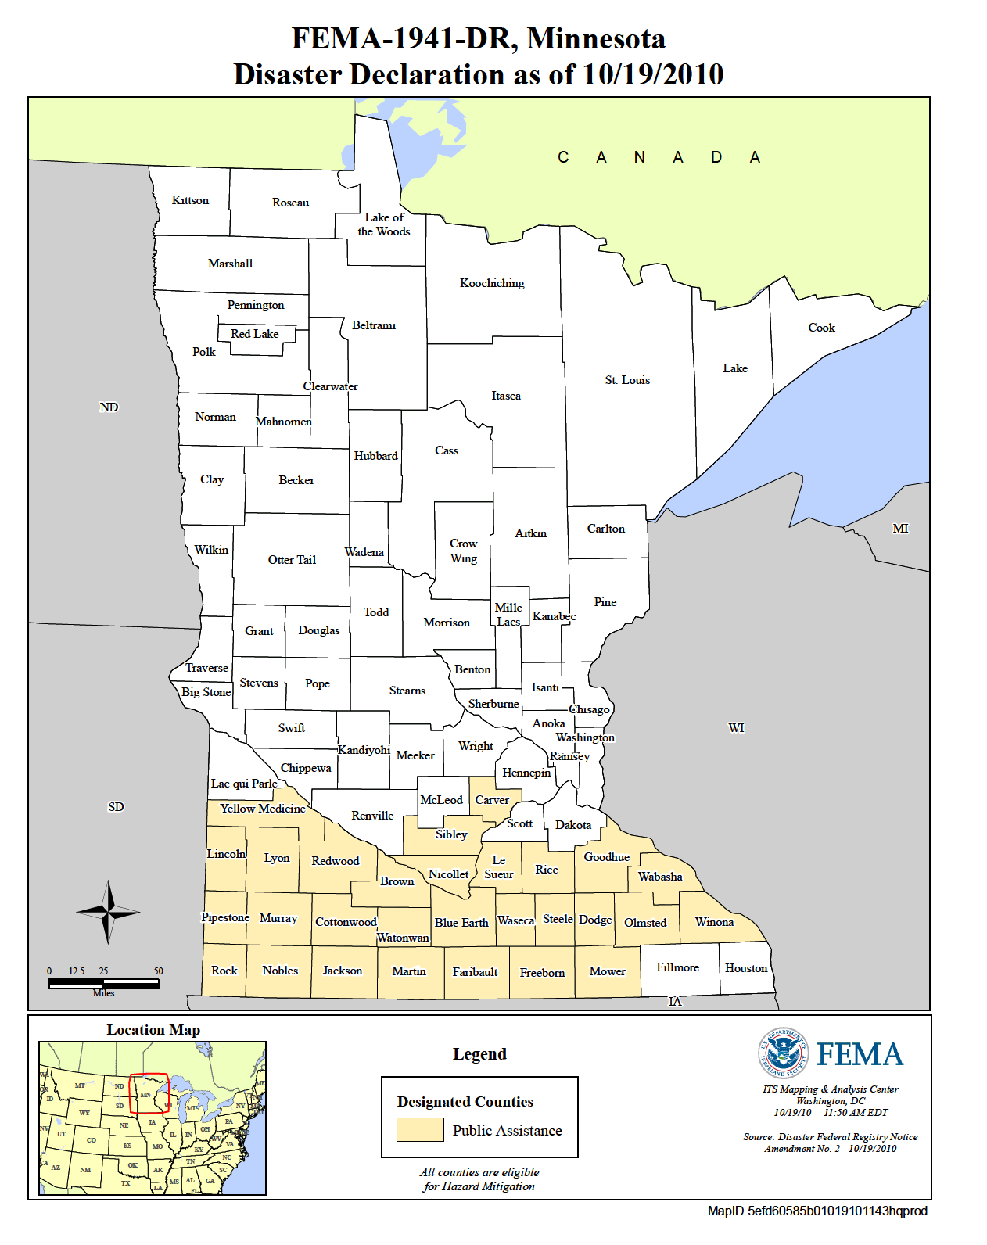  - April 20, 2018 – 8:30 am – 3:30 PM  - South Central College - Mankato, MN  Disaster Behavioral Health: Providing a Psychologically Supportive Response in a Disaster – Train-the-trainer  Objective:  To build community resilience by increasing awareness and understanding of the emotional impact of disasters and how to assist in reducing traumatic stress by training others in Disaster Behavioral Health: Providing a Psychologically Supportive Response.  This training is relevant to the Medical Reserve Corps volunteers, social services, emergency management, law enforcement, health care facilities, and individuals who work with in the community.  - Must have completed the 1-day basic training.
  Training for Non-Behavioral Health Disaster Responders
  ____
  Build community and individual resilience!
  ____
  Understand how to help yourself, your family, your friends, and your community during a disaster.
  ____
  Meet and network with your disaster response partners
  ____
  Register at https://www.train.org/mn
  Course ID 1069583
  
  MN behavioral health medical reserve corp
  