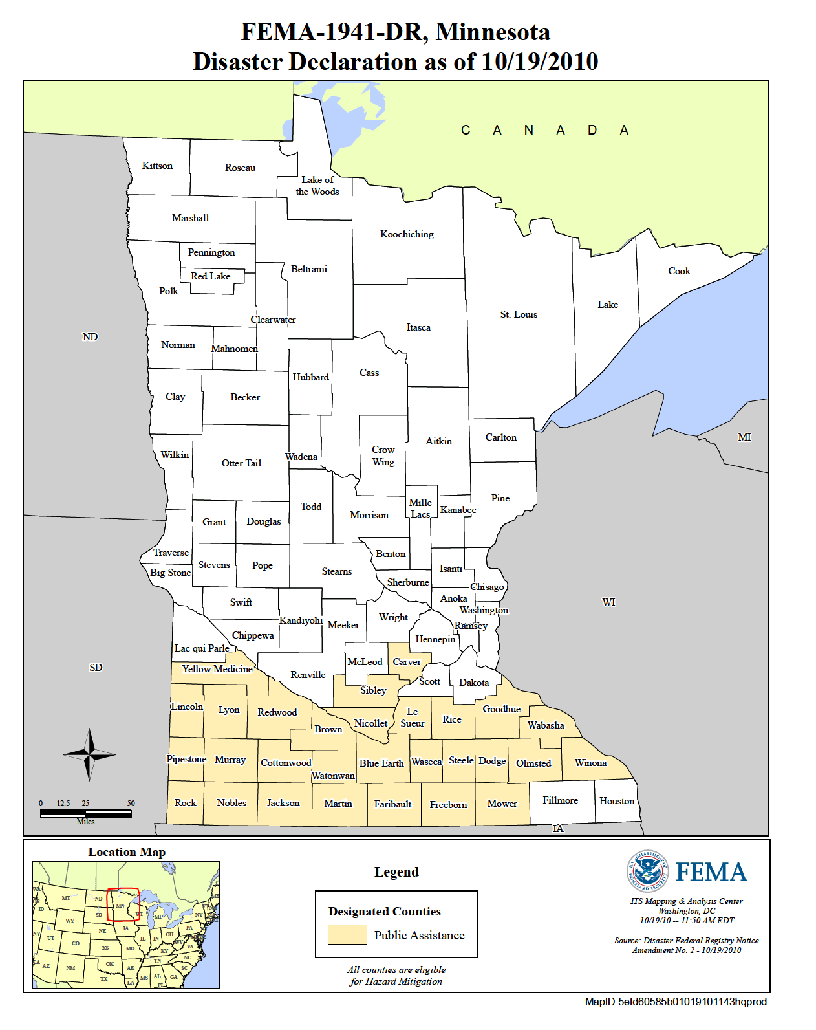  - April 19, 2018 – 8:00 am – 4:30 PM  South Central College - Mankato, MN  Disaster Behavioral Health: Providing a Psychologically Supportive Response in a Disaster  Learn  - How to recognize and manage the mental/behavioral health impacts of a disaster.  - Disaster behavioral health interventions and tools.  - Self-care for responders and teams.  - About ways to integrate behavioral health into local systems of response and recovery.  This training is relevant to the Medical Reserve Corps volunteers, social services, emergency management, law enforcement, health care facilities, and individuals who work with in the community.
  Disaster Behavioral Health Training for Non-Behavioral Health Disaster Responders
  ____
  Build community and individual resilience!
  ____
  Understand how to help yourself, your family, your friends, and your community during a disaster.
  ____
  Network with response partners
  ____
  - Register at https://www.train.org/
  Course ID 1069580
  
  MN behavioral health medical reserve corp
  